Cher Frere Blanc
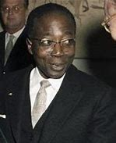
The poem was written by Leopold Senghor a Senegalese Poet. In the country of Senegal French is the most common language spoken, in fact it is the national language. Leopold was born in the city of Joar in Senegal on 9 October 1906 and he died in Normandy on 20 December 2001. As well as this in 1983 he also served as the first president of Senegal. He wrote the poem to help bring attention to the racism that was very much present back then.

He makes the poem humorous but at the same time he makes sure that he gets the point across. This poem is taught to school children all across France. It’s Mostly taught in year 7. He was a respected and loved man all across Senegal and France.

